|  |  |
| --- | --- |
|  | **2013** |
|  | School of Computer Science  207502969 Senzo Maphumulo |

|  |
| --- |
| **[Bank note recognition user manual]** |
| COMP702 Project |

**Running the program**

To run this application click file on the menu bar then click open and browse the image by using the file chooser the will pop up. One the image is loaded it is automatically converted to greyscale image. Preprocessing can be done by choosing the methods one the menu bar.at the right hand side of the frame there are two buttons one for classification and the other to view histogram.

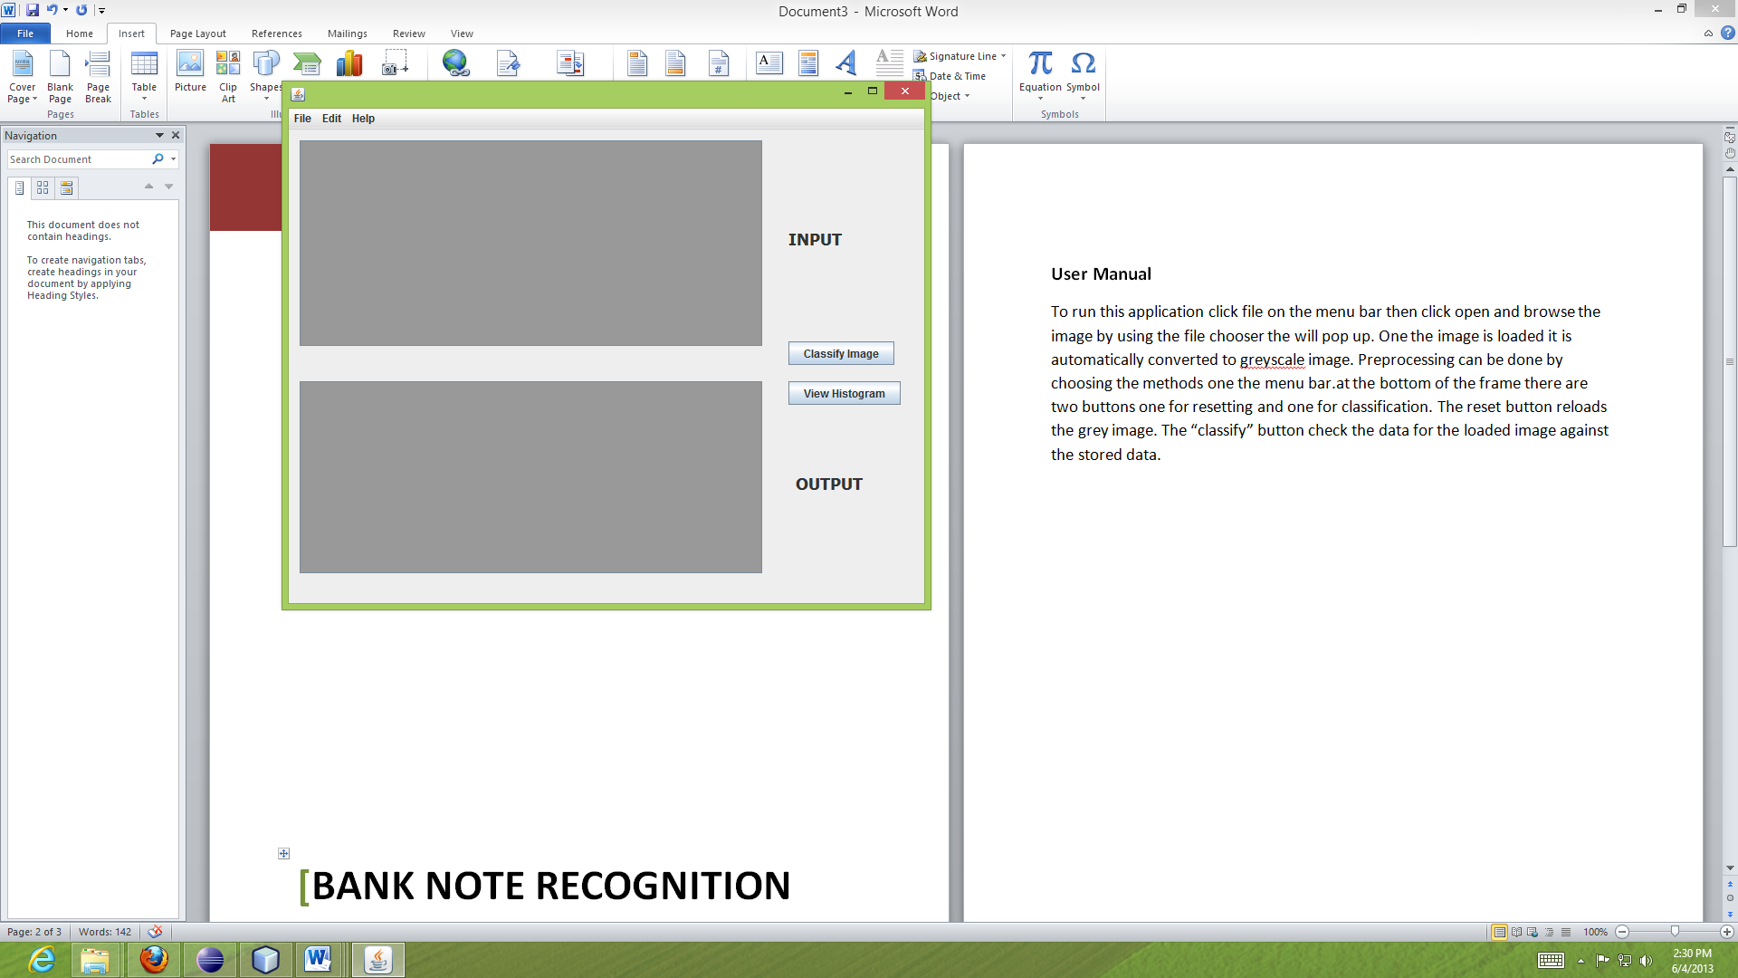

**The menu bar**

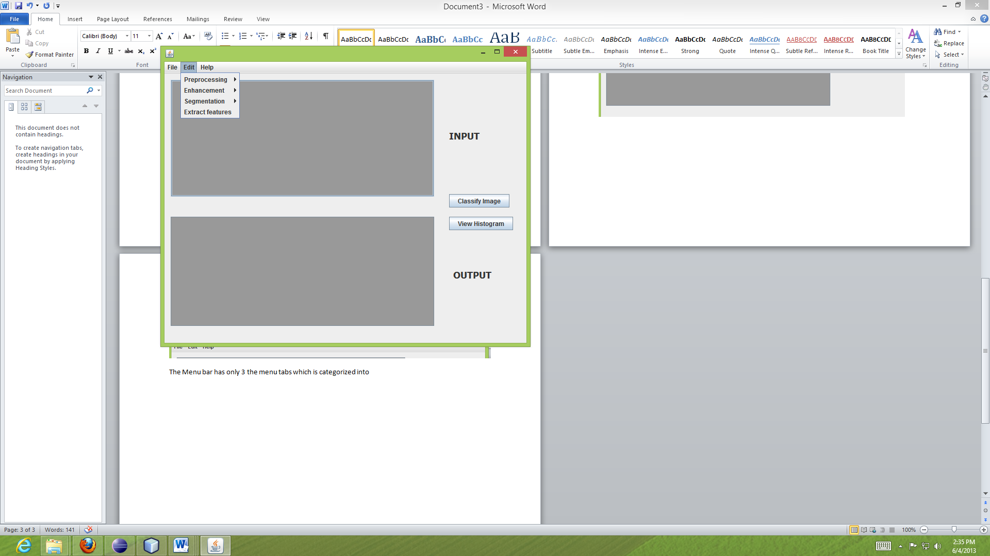

The Menu bar has only 3 the menu tabs which is categorized into four submenus for preprocessing, Enhancement, segmentation and extract image features.

**Display**

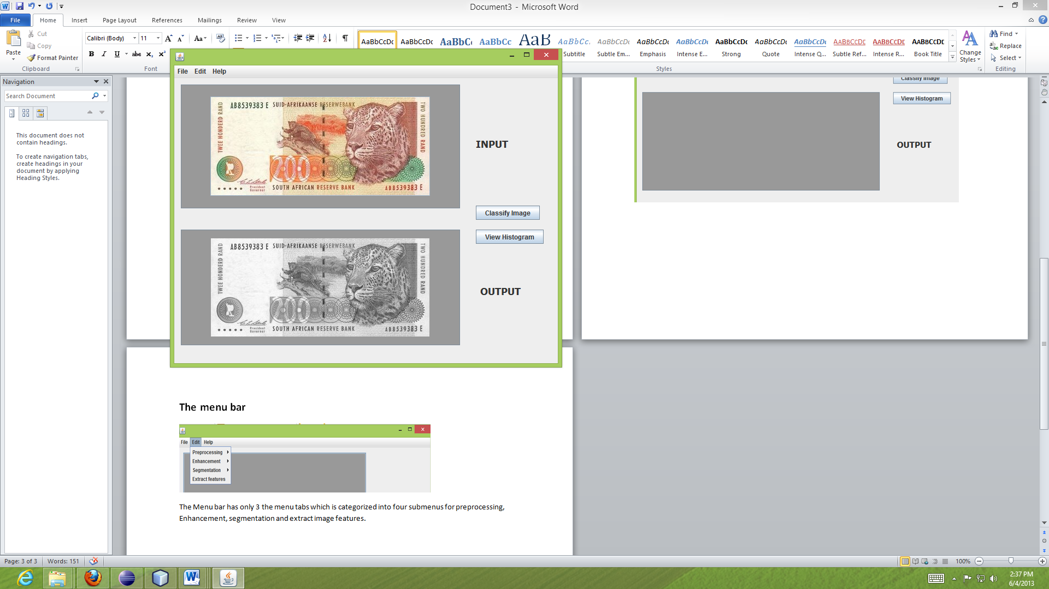

The system is divided into two panels, one for original image and the other for the processed image.

**Histogram View**

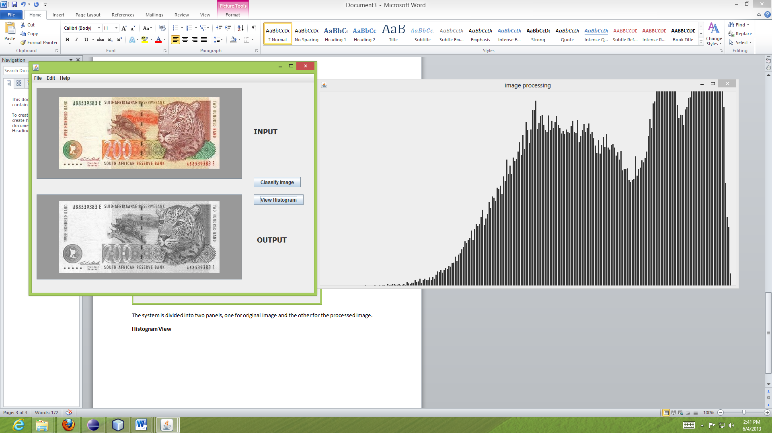

To view the histogram of the image simply click the view histogram button and the histogram will pop up in a new window.

**Classification of the image**

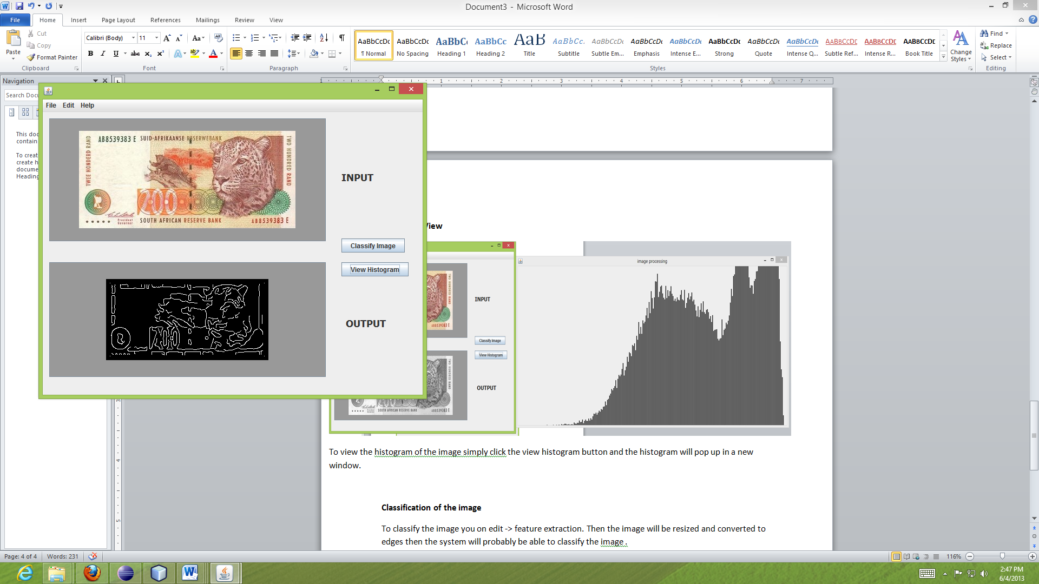

To classify the image you on Edit -> feature extraction. Then the image will be resized and converted to edges then the system will probably be able to classify the image. Note: If you click Extract features more than once, the edges will change and the system may not be able to classify.